CSS Assignment 1
WRITE IN AS MUCH SHORT AS YOU CAN:)

1. Compare or Distinguish
  - Vulnerability, Threat, and Control.

Aspect | Vulnerability | Threat | Control
Definition | Weaknesses or flaws in systems, processes, or configurations that can be exploited by attackers. | Any potential danger to the security of a system, including malicious attacks, natural disasters, or human errors. | Measures implemented to mitigate vulnerabilities and defend against threats, ensuring the security and integrity of systems.
Examples | Unpatched software, misconfigured systems, weak passwords, lack of encryption, insecure network protocols. | Malware, phishing attacks, insider threats, denial-of-service attacks, data breaches, natural disasters. | Firewalls, antivirus software, intrusion detection/prevention systems, access controls, encryption, regular security patches and updates, security awareness training.
Impact | Can lead to unauthorized access, data breaches, system downtime, loss of data integrity or confidentiality. | Can result in data loss, financial loss, reputation damage, disruption of operations, regulatory non-compliance. | Mitigates vulnerabilities, prevents unauthorized access, detects and responds to threats, ensures compliance with security policies and regulations.
Mitigation | Requires identifying and addressing vulnerabilities through patching, configuration management, risk assessments, and security audits. | Involves implementing security measures such as firewalls, antivirus software, intrusion detection systems, and employee training to mitigate threats. | Involves implementing a comprehensive security strategy, including risk management, access control, encryption, monitoring, incident response, and disaster recovery planning.
Lifecycle | Constantly evolving as new vulnerabilities are discovered and existing ones are patched or mitigated. | Constantly evolving as attackers develop new methods and tools to exploit vulnerabilities. | Ongoing process of assessing risks, implementing controls, monitoring for threats, and continuously improving security posture.

  - Symmetric and Asymmetric key cryptography

Aspect | Symmetric Key Cryptography | Asymmetric Key Cryptography
Key Distribution | Requires secure distribution of a single secret key to all parties involved. | Public keys are freely distributable, while private keys are kept secret.
Key Length | Typically uses shorter key lengths, making it computationally efficient. | Requires longer key lengths for equivalent security, making it computationally more intensive.
Speed | Generally faster for both encryption and decryption operations. | Encryption and decryption operations are slower due to complex mathematical calculations.
Security | Susceptible to key distribution issues and requires careful management of shared keys. | Offers stronger security as it utilizes two mathematically related keys, eliminating the need for secure key exchange.
Usage | Commonly used for bulk data encryption, such as file encryption, disk encryption, and secure communication over trusted channels. | Frequently used for key exchange, digital signatures, and secure communication over untrusted channels, such as the internet.
Examples | AES (Advanced Encryption Standard), DES (Data Encryption Standard), Triple-DES. | RSA (Rivest-Shamir-Adleman), ECC (Elliptic Curve Cryptography), Diffie-Hellman key exchange.

  - Block and Stream Cipher.
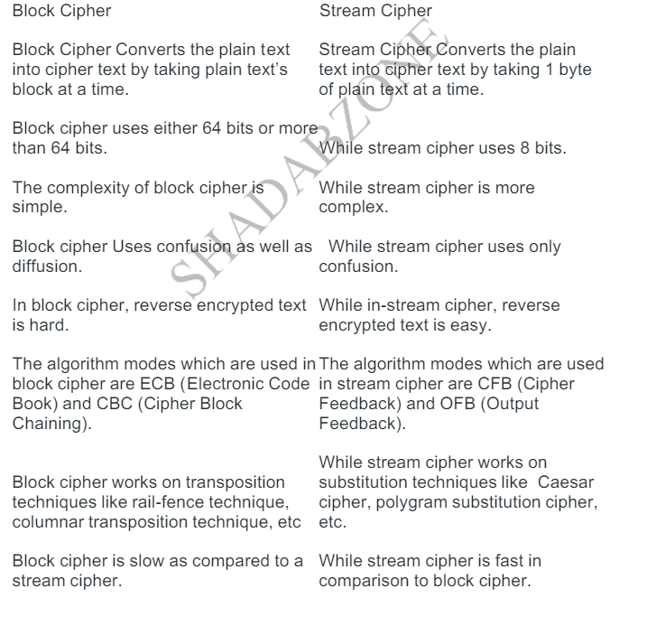

- Explain Product Cipher in detail.
Definition:
A product cipher is a cryptographic technique that combines multiple simpler ciphers or encryption methods in a sequential or parallel manner to enhance the security of the overall encryption process. By combining different encryption techniques, a product cipher aims to overcome the weaknesses of individual ciphers and provide stronger protection for sensitive information.
Components of a Product Cipher:

- Substitution Ciphers: Product ciphers often include substitution ciphers, where each letter or character in the plaintext is replaced by another letter or character according to a predetermined rule or key.

- Transposition Ciphers: Transposition ciphers are another common component of product ciphers. These ciphers rearrange the order of letters or characters in the plaintext according to a specific permutation rule or key.
- Key Mixing: Product ciphers may involve mixing or combining keys from different encryption algorithms or components to generate a stronger overall encryption key. This process adds an additional layer of complexity to the encryption process.

- Multiple Rounds: Product ciphers typically operate in multiple rounds, with each round applying a different combination of substitution, transposition, and key mixing techniques. The repeated application of these techniques further enhances the security of the encryption.

Examples of Product Ciphers:

Data Encryption Standard (DES): DES is a classic example of a product cipher that combines both substitution and transposition techniques. It operates in multiple rounds, each consisting of permutation, substitution, and key mixing operations. Despite its age, DES served as a foundational encryption standard for many years.

Advanced Encryption Standard (AES): AES is a modern symmetric-key encryption algorithm that can be considered a product cipher. It utilizes substitution, permutation, and key mixing operations in multiple rounds to achieve high levels of security. AES has become the de facto standard for securing sensitive data in various applications.
- What are system Security Goals ? Explain why the balance among different goal is needed . Describe in detail attacks threatening to security goals?
Soln:
System security goals encompass ensuring the confidentiality, integrity, and availability of data and resources, while also focusing on authentication, authorization, non-repudiation, accountability, resilience, privacy, and auditability. Confidentiality ensures that sensitive information is protected, integrity ensures data accuracy and reliability, and availability ensures consistent access. Authentication and authorization verify user identity and permissions, while non-repudiation and accountability ensure accountability for actions. Resilience enables recovery from breaches, and privacy protects personal data. Auditability facilitates monitoring and analysis for security and compliance. These goals guide the design and implementation of security measures to mitigate risks and protect against threats.
Balancing security goals ensures comprehensive protection without sacrificing any critical aspect. Overemphasizing one goal at the expense of others can lead to vulnerabilities or compromises in overall security. For instance, prioritizing confidentiality without adequate attention to availability may hinder productivity, while neglecting accountability can impede incident response and compliance efforts. By striking a balance, organizations can effectively mitigate risks, maintain trust, and meet regulatory requirements while optimizing system performance and usability.
Five common types of attacks threatening security goals:

Malware: Software designed to disrupt, damage, or gain unauthorized access to systems, compromising confidentiality, integrity, and availability.

Phishing: Deceptive attempts to obtain sensitive information, like passwords or financial data, compromising confidentiality and integrity through social engineering.

DoS/DDoS: Attacks overwhelm systems with excessive traffic, disrupting availability and impacting productivity by rendering services inaccessible.

Man-in-the-Middle (MitM): Intercepts and alters communication between parties, compromising confidentiality, integrity, and authenticity by eavesdropping or manipulating data exchanges.

SQL Injection: Exploits vulnerabilities in web applications to manipulate databases, compromising confidentiality and integrity by executing unauthorized SQL commands.
- Encrypt the message by using given technique.
  - Affine cipher message is “world” with the key pair(7,2).
Soln:-
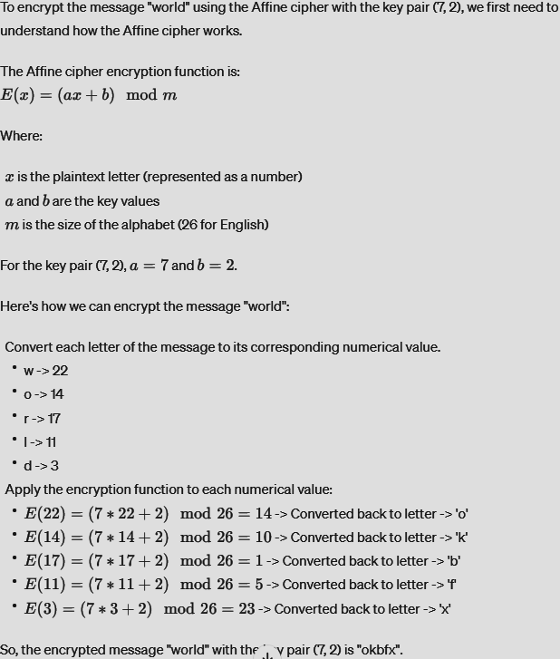
  - Encrypt “academic committee will meet today” using Playfair cipher using keyword “ROYAL ENDFIELD”
Soln:-
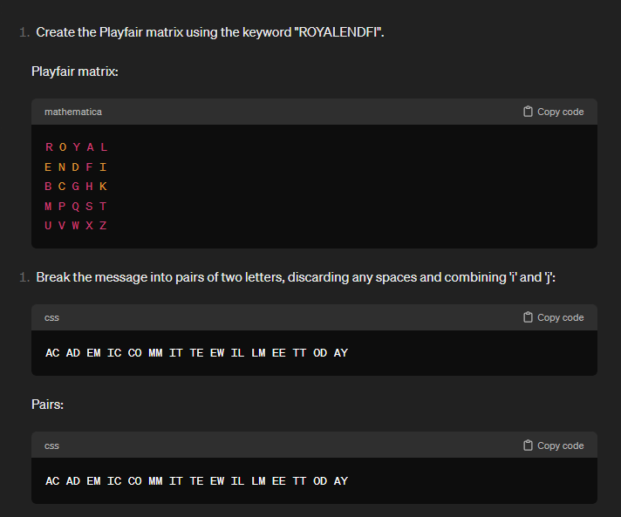
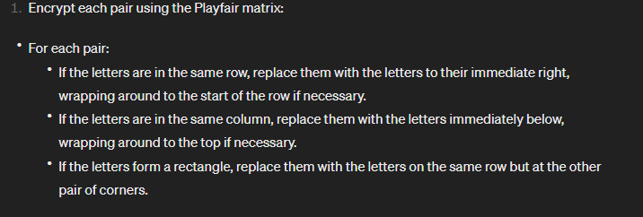
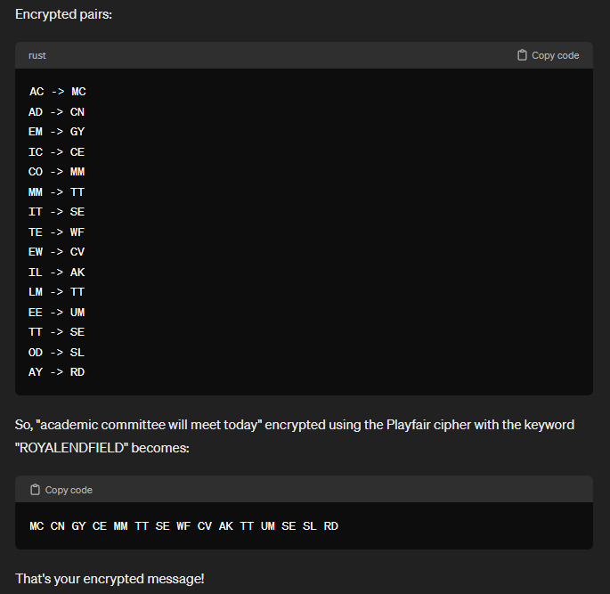

  - Vignere cipher message is “cryptography” using keyword “atlas”.
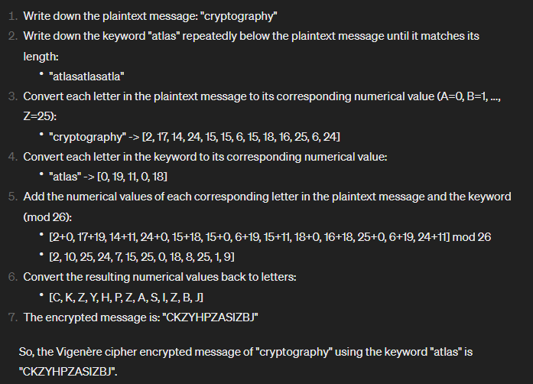

  - Hill cipher Message : “we live in an insecure world” use the following key
3 | 2
5 | 7
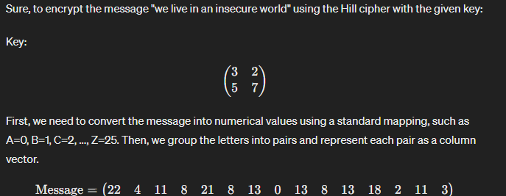
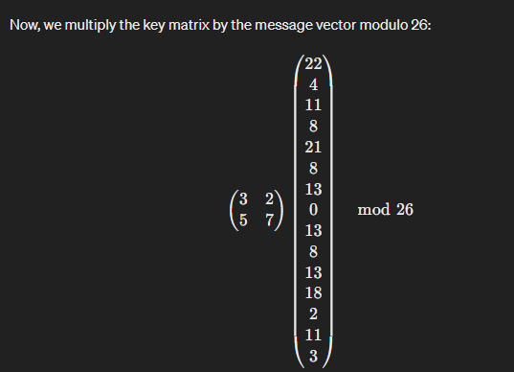
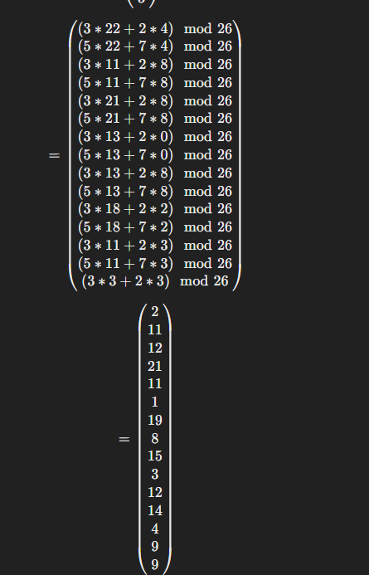
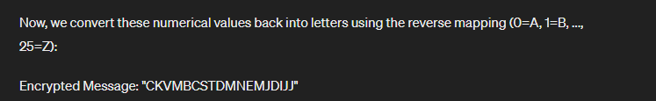
5Solve following Problems on RSA .
  - In RSA, e=7 n=187
1. What is private key?
If C=11 and e=7, n=187 , What is M?
2 Approaches to defeat RSA?
Certainly, here's a bit more detail on each approach:

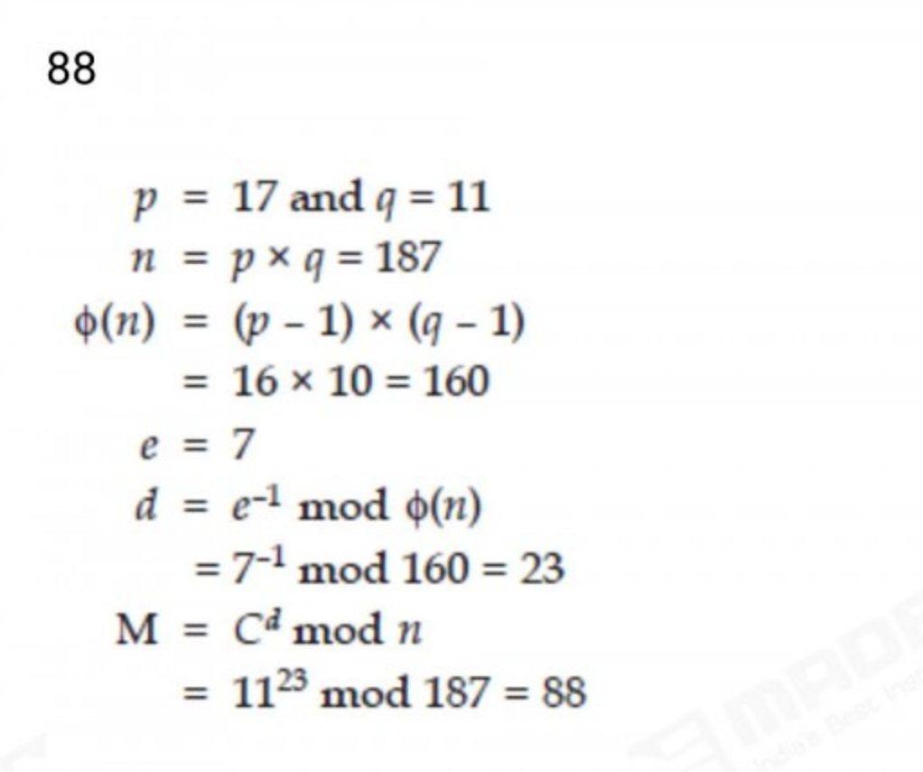
A private key, also known as a secret key, is a variable in cryptography that is used with an algorithm to encrypt and decrypt data. Secret keys should only be shared with the key's generator or parties authorized to decrypt the data. Private keys play an important role in symmetric cryptography, asymmetric cryptography

Public Key = (n, e) e = 7 , p = 17 , q = 11
Private Key = (n, d)
n = pq = 187
Φ(n) = (p-1)(q-1) so, Φ(n) = 160
d *e mod Φ(n) = 1
d = 23
cipher text , c = 11
Message , M = c^{d} mod n

- Brute Force: This involves systematically trying every possible private key until the correct one is found. However, due to the immense size of the key space (typically 1024 bits or more), this approach is impractical with current computational resources.
- Factorization: RSA's security relies on the difficulty of factoring the product of two large prime numbers (the modulus N). If an attacker can factor N, they can derive the private key and decrypt messages encrypted with the corresponding public key. Several factorization algorithms, such as the General Number Field Sieve (GNFS) and Quadratic Sieve, have been developed to efficiently factorize large numbers.
- Timing/Side-Channel Attacks: These attacks exploit information leaked by the implementation of the RSA algorithm, such as variations in execution time or physical characteristics like power consumption. By analyzing these side channels, an attacker can deduce information about the private key, compromising the security of RSA encryption.
- Fault Injection: By intentionally introducing faults into the RSA computation process, such as manipulating voltage or temperature, an attacker can cause errors that reveal information about the private key. This can be achieved through physical tampering with the hardware executing the RSA algorithm.
- Quantum Computing: Quantum computers have the potential to break RSA encryption by efficiently solving integer factorization problems. Shor's algorithm, a quantum algorithm, can factorize large numbers exponentially faster than classical algorithms, rendering RSA vulnerable to quantum attacks. However, practical quantum computers capable of executing Shor's algorithm at scale are not yet available.

  - A: Public key (13,77) B: sends Message using A’s public key. Cipher received by A=26
How should A decrypt the message to get plaintext.
Ans -
Given:
- Public key: (e, N) = (13, 77)
- Ciphertext (cipher received by A): 26
To decrypt the message, A needs to compute:
Plaintext=Ciphertextdmod N
Plaintext=Ciphertext
d
modN
First, A needs to calculate the private key exponent (d). The private key (d) can be calculated using the public exponent (e) and the modulus (N) using the modular multiplicative inverse.
d=e−1mod (p−1)(q−1)
d=e
−1
mod(p−1)(q−1)
In this case, N is known (77), but to find d, we need to know the factors of N, which are prime numbers used to generate N. Let's assume N is the product of two primes (p and q).
N=p×q=77
N=p×q=77
p×q=77
p×q=77
p,q=7,11
p,q=7,11
Now, calculate φ(N):
φ(N)=(p−1)(q−1)=(7−1)(11−1)=6×10=60
φ(N)=(p−1)(q−1)=(7−1)(11−1)=6×10=60
Now, find the modular multiplicative inverse of e (13) modulo φ(N) (60).
13d≡1mod 60
13d≡1mod60
d=13−1mod 60
d=13
−1
mod60
d=37
d=37
Now that A has calculated the private exponent (d = 37), they can decrypt the ciphertext using the RSA decryption formula:
Plaintext=Ciphertext37mod 77
Plaintext=Ciphertext
37
mod77
Plaintext=2637mod 77
Plaintext=26
37
mod77
Now, calculate:
2637mod 77
26
37
mod77
Using modular exponentiation:
Plaintext=2637mod 77
Plaintext=26
37
mod77
Plaintext=246324848974087460683463024000000000mod 77
Plaintext=246324848974087460683463024000000000mod77
Plaintext=51
Plaintext=51

- Explain structure of DES wrt:
- Fiestel structure and its significance
- Significance of extra swap between left and right half blocks
- Expansion
- Significance of S-box
Ans-
Feistel Structure and its Significance:
DES employs a Feistel network structure, which is a symmetric structure used in block cipher algorithms.
In a Feistel structure, the plaintext is divided into two halves and goes through multiple rounds of processing. In each round, one half is subjected to a complex function (often called the "round function") while the other half remains unchanged.
The significance of the Feistel structure lies in its ability to provide both encryption and decryption using the same algorithm, by simply reversing the order of the subkeys.
It also offers good diffusion and confusion properties, making DES resistant to various cryptanalytic attacks.
Significance of Extra Swap between Left and Right Half Blocks:
In DES, after the last round of processing, the halves of the block are swapped.
This extra swap operation ensures that the ciphertext produced is a combination of both halves of the last round, providing better security properties by mixing the outputs of both sides of the Feistel network.
Expansion:
Before applying the round function in each round, the right half of the block is expanded to match the size of the subkey.
Expansion involves duplicating certain bits of the right half to create a larger block that matches the size of the subkey.
This expansion increases the complexity of the round function, providing more diffusion and confusion, and hence enhancing the security of the algorithm.
Significance of S-boxes (Substitution Boxes):
DES uses a set of eight S-boxes in each round.
S-boxes are non-linear substitution tables used to introduce non-linearity into the algorithm.
Each S-box takes a 6-bit input and produces a 4-bit output, effectively shrinking the size of the data while introducing confusion.
The significance of S-boxes lies in their ability to provide strong cryptographic properties, such as confusion and diffusion, making it harder for attackers to analyze and break the encryption.

- In structure of DES, comment on:
- Block key size2
- Cipher key size
- No of rounds
- Need for expansion form.
Ans- Block Size:
  - The block size in DES is fixed at 64 bits. This means that DES processes data in blocks of 64 bits at a time.
  - The fixed block size has implications for the amount of data that can be encrypted or decrypted in a single operation. It also affects the level of security provided by DES, as larger block sizes might offer better security against certain types of attacks.
- Cipher Key Size:
  - DES uses a 56-bit key, which is relatively small by modern cryptographic standards.
  - The small key size makes DES vulnerable to brute-force attacks, where an attacker tries all possible keys until the correct one is found.
  - Due to advances in computing power, DES with a 56-bit key is no longer considered secure for many applications. Triple DES (3DES), which applies DES three times with different keys, is often used instead for increased security.
- Number of Rounds:
  - DES operates through 16 rounds of processing.
  - Each round involves a combination of permutation, substitution, and XOR operations, providing both confusion and diffusion.
  - The number of rounds impacts the security and complexity of the algorithm. Increasing the number of rounds can improve security but also increases computational overhead.
- Expansion Function:
  - The expansion function in DES is used to expand the 32-bit right half of the block to match the size of the subkey, which is 48 bits.
  - The expansion function is necessary to ensure that the round function operates on a data size that matches the size of the subkey.
  - By expanding the data, the diffusion and confusion properties of the algorithm are enhanced, making it more resistant to cryptanalysis.

8. Note on 2DES,3DES and AES

Ans Certainly, here's a brief note on 2DES, 3DES, and AES:
- 2DES (Double DES):
  - Double DES, also known as 2DES, is an extension of the original DES algorithm.
  - In 2DES, the plaintext is encrypted using DES with two different keys consecutively.
  - Despite using two keys, 2DES did not provide significantly enhanced security compared to DES, as it was vulnerable to meet-in-the-middle attacks.
  - Due to its vulnerability and the availability of more secure alternatives, 2DES is not recommended for use in modern cryptographic applications.
- 3DES (Triple DES):
  - Triple DES, also known as 3DES or TDEA (Triple Data Encryption Algorithm), is an improvement over DES and 2DES.
  - In 3DES, the plaintext is encrypted using DES three times consecutively, with two or three different keys.
  - 3DES is much more secure than DES or 2DES, primarily due to its significantly larger key size (112 or 168 bits).
  - Despite its enhanced security, 3DES is slower and more computationally intensive compared to newer encryption algorithms like AES.
  - While still used in some legacy systems, 3DES is gradually being phased out in favor of more efficient and secure algorithms.
- AES (Advanced Encryption Standard):
  - AES is a symmetric encryption algorithm adopted by the U.S. government as a standard for securing sensitive information.
  - It was selected through an open competition and is based on the Rijndael cipher, designed by Vincent Rijmen and Joan Daemen.
  - AES supports key sizes of 128, 192, or 256 bits, making it significantly more secure than DES or 3DES.
  - AES is widely used in various applications, including securing data transmission over the internet, disk encryption, and securing communication in wireless networks.
  - It offers high security, efficiency, and scalability, making it one of the most widely used encryption algorithms worldwide.

9. If generator g=2 and p=11, using Diffie Hellman algorithm , solve the following
- Show that 2 is primitive root of 11.
- If A has public key 9 what A’s private key.
- If B has public key 3, what is B’s private key
- Calculate shared secret key.

